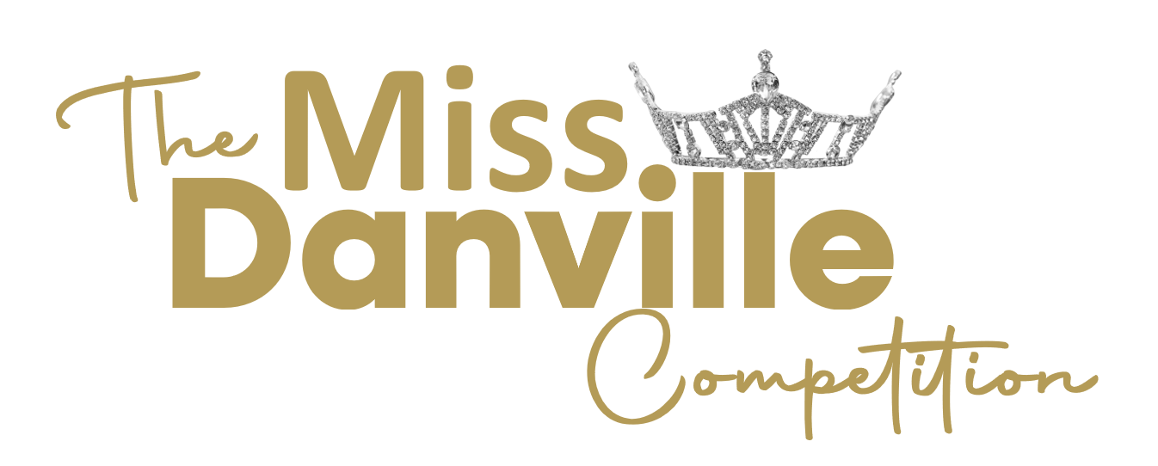

Talent Request
(Talent max of 90 seconds)

Contestant Name: ___________________ Candidate Division:________
Type of Talent (Vocal, Dance, Monologue, Herstory, etc.): __________________
Title of Talent: _________________________________
Written By: ____________________________________________________
Talent Introduction (to be read by emcee, 35 words or less):

All Music must be sent digitally to Missdanville@gmail.com

