Danville

The
Miss

Competition

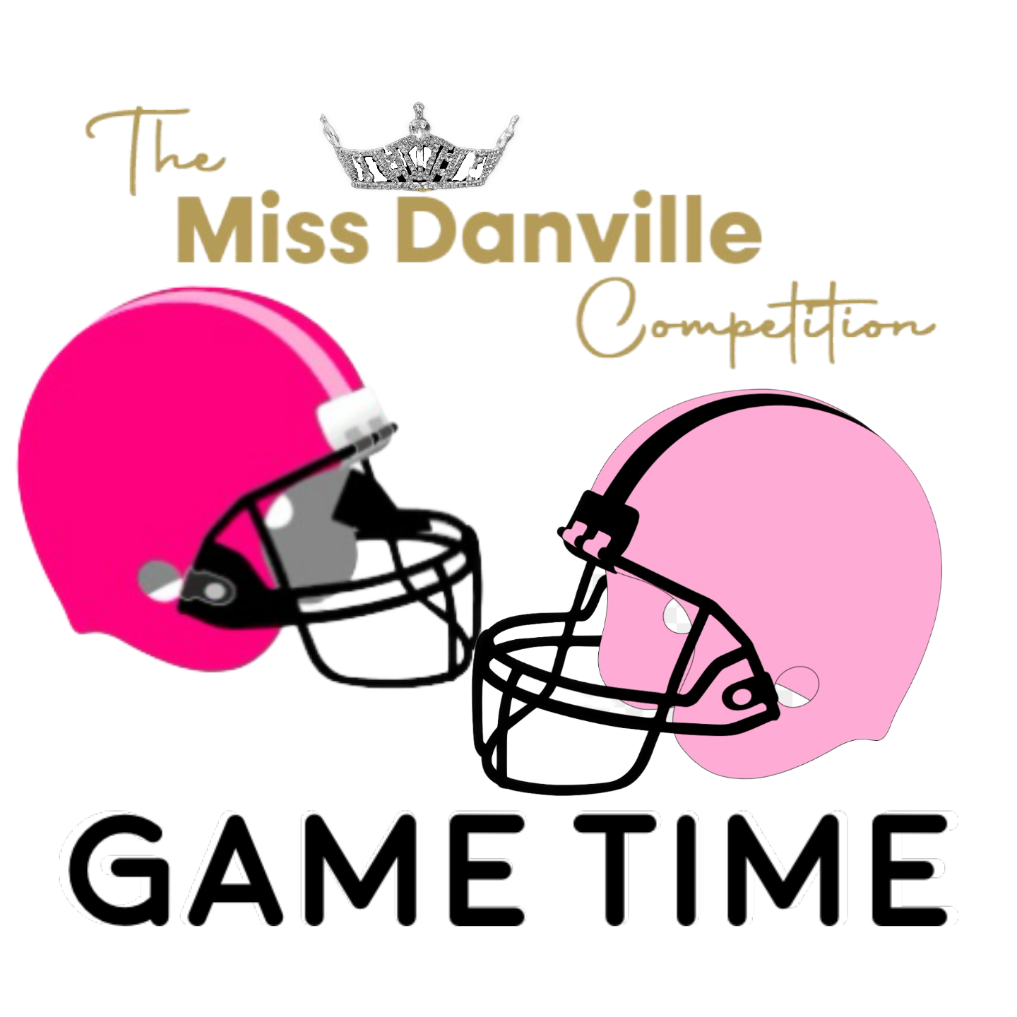

Put your game face on!! This is your invitation to become a candidate in the 2025 Miss Danville Outstanding Teen, and Miss Danville Competition. We are planning an exciting event for August 10, 2024, and our venue is the Boyle County Performing Arts Center! Our theme for this year’s competition is “FOOTBALL”. Our hope is that every Contestant will leave our event with more confidence and feeling empowered to become more passionate about their causes, more committed to their goals, and more focused on making positive change in their schools and communities.
****APPLICATION DEADLINE Wednesday, July 10, 2024****
Opening number attire for contestants will be a White/Pink Football Jersey (provided) and any black bottoms. All contestants will compete in Interview, Fitness, On stage conversation, Talent, and Evening Gown. Both Teen and Miss Contestants will compete for the “Leadership Award” which will go to the contestant who is shown to be a strong leader through her community service and school and community activities. There will also be a “Spirt Award”, and “Community Service Award”, additional awards may be added depending on the number of contestants.

All Candidates will need a Miss Danville Little Sister. The cost for your Sister will be $100 and she will receive (2) tickets to the competition, gift bag, crown, sash, and will have a Tea Party. She will appear on stage with each contestant during Evening Gown and will be featured in a dance number. Entry fee for Teen and Miss Contestants is $150 paid to Miss Danville. Payments can be made through Venmo @missdanville or Paypal missdanville@gmail.com.

Each Candidate has the option to sell Ads for the program book. Cost of Ad sales are ¼ page $50.00, ½ page $75.00, and Full Page $150.00. There will be a Cash Scholarship to the contestant that sells the most ADS. All ADS are due by July 20, 2024.

Placement will be decided in the reverse order of the paperwork received. (Example first application will compete last in their age group) Please email all paperwork and headshot to missdanville@gmail.com by the deadline. Payments should be made through PayPal to missdanville@gmail.com or Venmo @missdanville.

Best regards,
Reuben Harness
Angela Todd Executive Co-Directors
Miss Danville Scholarship Organization

