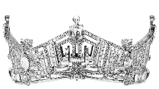
The
Miss

Danville

Competition

Approved Performing Arts & Talent List
Vocal Dance
Instruments Gymnastics (all types)
Baton Twirling Painting
Magic Stand Up Comedy
Dramatic Reading Monologues
Slam Poetry Spoken Word
Flags or Color Guard Presentation Martial Arts Demo
Silks Roller Skating
Hula Hoops Balancing Acts
Unicycling Juggling
Theatrical Science Experiments Ventriloquism
Rodeo/Roping Cheerleading
Contortionist Signing
Storytelling (HerStory)

